BrewCode POS
Submitted by:
C2 na Red
Date:
[Submission Date]

Introduction
Our Software Engineering project, Cafe Management System, is designed to streamline the operations of a small to medium-sized cafe. It assists cafe managers in managing customer orders, inventory levels, and staff schedules efficiently. The system provides real-time updates on inventory and sales, enabling managers to make informed decisions on a day-to-day basis. A relational database is essential for storing and managing the data, ensuring data integrity and facilitating efficient data retrieval.

Business Rule
- A customer can place multiple orders.
- Each order can contain multiple items.
- Each item can be part of multiple orders.
- Inventory levels are updated based on order quantities.(Islan ja nga ma change inventory based sa owner, then amu na ma change ang items)
- Staff members can handle multiple orders.
- Each order is linked to a specific staff member and customer.

Data Constraints
- NOT NULL: Customer name, Order date, Item name, Staff name
- UNIQUE: Customer ID, Item ID, Staff ID
- CHECK: Inventory quantity must be greater than or equal to 0
- PRIMARY KEY: Unique identifiers for all main tables (CustomerID, ItemID, OrderID, StaffID)
- FOREIGN KEY: Relationships between tables (e.g., Order table links Customer and Staff)

Entities and Relationships
- Customer (customerID, fullName)
- Items (id, itemName, price)
- Order (id, customerID, staffID, date, totalAmount)
- OrderItem (orderID, imtemID, quantity)
- Staff (staffID, name)
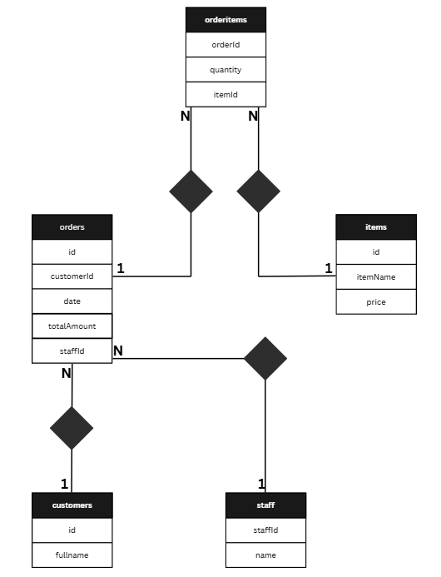

Figure 1: ERD in Chen's Notation

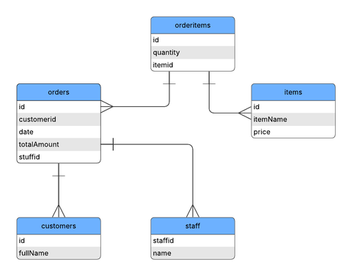

Figure 2: ERD in Crow's Foot Notation

Tables - with Primary and Foreign Key
EXAMPLE:
***With Picture of Table either in cmd or phpmyadmin
Student Table
· StudentID (Primary Key)
· FirstName
· LastName
· DateOfBirth
· Email
Course Table
· CourseCode (Primary Key)
· CourseName
· Credits
Enrollment Table
· EnrollmentID (Primary Key)
· StudentID (Foreign Key references Student(StudentID))
· CourseCode (Foreign Key references Course(CourseCode))
· Semester
· Grade
SQL Queries
EXAMPLE at least 20 sql:
1. SELECT * FROM Student;
2. SELECT * FROM Course;
3. SELECT * FROM Enrollment;
4. SELECT FirstName, LastName FROM Student WHERE DateOfBirth > '2000-01-01';
5. SELECT CourseName FROM Course WHERE Credits >= 3;
6. SELECT * FROM Enrollment WHERE Grade BETWEEN 85 AND 100;
7. SELECT COUNT(*) FROM Student;
8. SELECT AVG(Grade) FROM Enrollment;
9. SELECT s.FirstName, s.LastName, e.Grade FROM Student s JOIN Enrollment e ON s.StudentID = e.StudentID;
10. SELECT c.CourseName, COUNT(e.StudentID) AS EnrolledStudents FROM Course c JOIN Enrollment e ON c.CourseCode = e.CourseCode GROUP BY c.CourseName;
11. SELECT * FROM Enrollment WHERE Semester = '2024-1';
12. SELECT DISTINCT Semester FROM Enrollment;
13. UPDATE Student SET Email = 'updatedemail@example.com' WHERE StudentID = 1;
14. DELETE FROM Enrollment WHERE Grade < 60;
15. INSERT INTO Student (StudentID, FirstName, LastName, DateOfBirth, Email) VALUES (101, 'Jane', 'Doe', '2001-05-14', 'jane.doe@example.com');
16. INSERT INTO Course (CourseCode, CourseName, Credits) VALUES ('CS101', 'Intro to Programming', 3);
17. INSERT INTO Enrollment (EnrollmentID, StudentID, CourseCode, Semester, Grade) VALUES (201, 101, 'CS101', '2025-1', 90);
18. SELECT MAX(Grade) FROM Enrollment;
19. SELECT MIN(Grade) FROM Enrollment;
20. SELECT s.FirstName, s.LastName, c.CourseName FROM Student s JOIN Enrollment e ON s.StudentID = e.StudentID JOIN Course c ON e.CourseCode = c.CourseCode;
***With picture of executed results

